**Instant Home Services**

D.Prem Kumar1

Department of Computer Science and Engineering

Sri Eshwar College of Engineering, Coimbatore,

premdeivasikamani[@gmail.com](mailto:premkumar@gmail.com)

B.Kirubhaharan2

Department of Computer Science and Engineering

Sri Eshwar College of Engineering, Coimbatore,

kirubhaharan1@gmail.com

P. Pradeesh3

Department of Computer Science and Engineering

Sri Eshwar College of Engineering, Coimbatore,

pradeeshprakasan17[@gmail.com](mailto:kirubhaharan1@gmail.com)

***Abstract— The Instant Home Services is a useful website that provides services such as Installation and Repairing for the Home Appliances like AirConditioner, refrigerators, Washing machines, Microwave, Mixer, Wet, Grinder, Television. Three users are being used in our system, the Home service providers, the user, and the admin who manages all the allocations and registering of service providers. The people who need the Home appliances Service can register through the website and get their services done by filling out the request form and getting confirmation from the admin about the service provider allocation. Service providers play a vital role in the Home Services thus the certified service providers are registered by the admin with complete information about the service provider. This system also provides a business opportunity for the service providers, by which the service provider can build their career and income. Once the user requests for a service, if the service is confirmed it will be allocated to a service provider in the locality by the admin. After the service completion, the bill containing all the charges including the service charge, if the spare parts are replaced their cost is added to the bill summary and the report is sent to the customer***

# **Introduction**

When someone requires repairing their appliances in their home Instant Home Services provides help for the user to get a service provider nearby them. Being an online platform, Instant Home Services connects internet users with offline workers. It takes a minimal amount of time to raise a request in Instant Home Service. This system connects skillful service providers to the users for their needs. The services which can be raised by the customers are Televisions, AirConditioner, Microwave, Mixer, Grinder, Refrigerator, etc.

This proposed system is similar to the ordering apps like ordering and getting items delivered. Here the user needs to raise a request and that request will be sent to the admin and then the admin assigns the best suitable service provider for the user based on the request raised. Once the task is assigned to the service provider the confirmation will be shown to both users as well as the service provider. At last, the system generates the bill for the service cost.

# **Survey**

Many already existing online platforms provide home services which are explained briefly

* URBAN CLAP has been providing service for users since 2014. But the main drawback of this system is that it only provides services in 14 major cities in India. (Ahmedabad, Bengaluru, Chandigarh, Chennai, Delhi, NCR, Hyderabad, Jaipur, Pune, Mumbai, Kolkata, Lucknow, Vadodara, and Visakhapatnam)
* TIMESAVERZ is an online marketplace for multiple home repair and maintenance services. It allows homeowners to post their household service requirements and uses its search algorithm to connect them with a service provider.
* HOUSEJOY is an online platform that provides home services and maintenance services for customers. They are also offering salon at home and pest control at-home services. The main drawback is that it works only in 12 locations across India.
* ZIMMBER is an online marketplace for requesting home services including painting, home painting, home cleaning, AC services, electrician, plumber, carpenter, and more. They are providing their services in some desired locations.

.

# **Existing System**

The present systems contain the service provider's fine print, which may be accessed by users who need domestic services performed. Gas, plumbing, and electrical services are among the services provided by the system. Users can look at the services available through the system and contact the actual suppliers to request them. To take advantage of the system's services, the user must first register. The system operates as a middleman between the user in need of services and the service provider who provides those services. Users can only acquire the fine print regarding service providers in the current system; they do not have the option to register for the services they desire, and hence cannot track such services. Users can submit feedback on the services that they have received. The modules that are currently available in the system are listed below.

A. USER MODULE

This module provides information about the services available. The purchasers will be able to obtain the service provider's address for the services that have been given. The users can also bookmark the services so that they can access them whenever they want.

B. ADMIN MODULE

This module contains administration-related features. Admin is in charge of all data related to the services, and they have the authority to make changes to the information on the provider's details.

C. PAYMENT

This module contains payment-related features. The user can pay only through cash to the service provider in the existing system.

D. FEEDBACK MODULE

Customers can leave feedback and concerns about the services that have been provided as well as the service providers. Admin can take the necessary actions based on the grievances and comments that have been received from the users.

E. REGISTRATION MODULE

Consumers who want to take advantage of the services are asked to complete the registration process. After that, an authorization email regarding a new account with a verification link is sent to the email address provided by the user during registration. After this step, the consumer will be able to utilize our services once their account has been verified.

# **Proposed System**

Our suggested project is a web application that uses PHP as the front end and SQL Server as the back end to help users obtain necessary services such as plumbing, electronic repair, gas stove repair, RO maintaining, and electrical maintenance. This website allows home service providers to register and add their basic information, including a phone number. Users can register on this website by entering basic information such as their name, address, phone number, and email address. After that, individuals can access the required services by logging in using their username and password.

By stating the location, the user can find a service provider. When a user needs a specific service, they can submit a request. The administrator receives the user's request. The administrator serves as a link between the user and the supplier. Admin contacts the specific providers and informs the clients of the status of the requested service through email. This enables the user to receive services without delay and eliminates the need for the user to rely on others to identify service providers.

The user needs to fill in the details in the request form for raising the request. The details are like Brand name, Nature of the problem, problem description, type of appliances, address, service date, a suitable time for service. Users can also withdraw the request after raising the request form.

The admin assigns the work which is raised by the user to the service provider nearby. Admin can also manage the service providers. Admin can also have the right to cancel the request raised by the user for inevitable reasons. In the Admin dashboard the details like the number of technicians, registered users, request raised, assigned requests, completed request, the new request will be available. Admin can also handle the home page content like modifying text, Images on the home page.

Once the request has been assigned by the admin to the technician. The new request will be intimated to the technician on their dashboard. After completing the service he/she can update it in their dashboard.

User, service provider, and admin logins are all included in the system. When a user logs in with his credentials, the service can be searched and retrieved from the database. The service provider can add and view services by logging in using their credentials. When a service is added, it is saved in the database and can be retrieved whenever the service is desired. The administrator can add service providers and see user information.

V.  **Modules in the proposed system**

The suggested system consists of four modules. In this part, the functionalities of these four modules are explored.

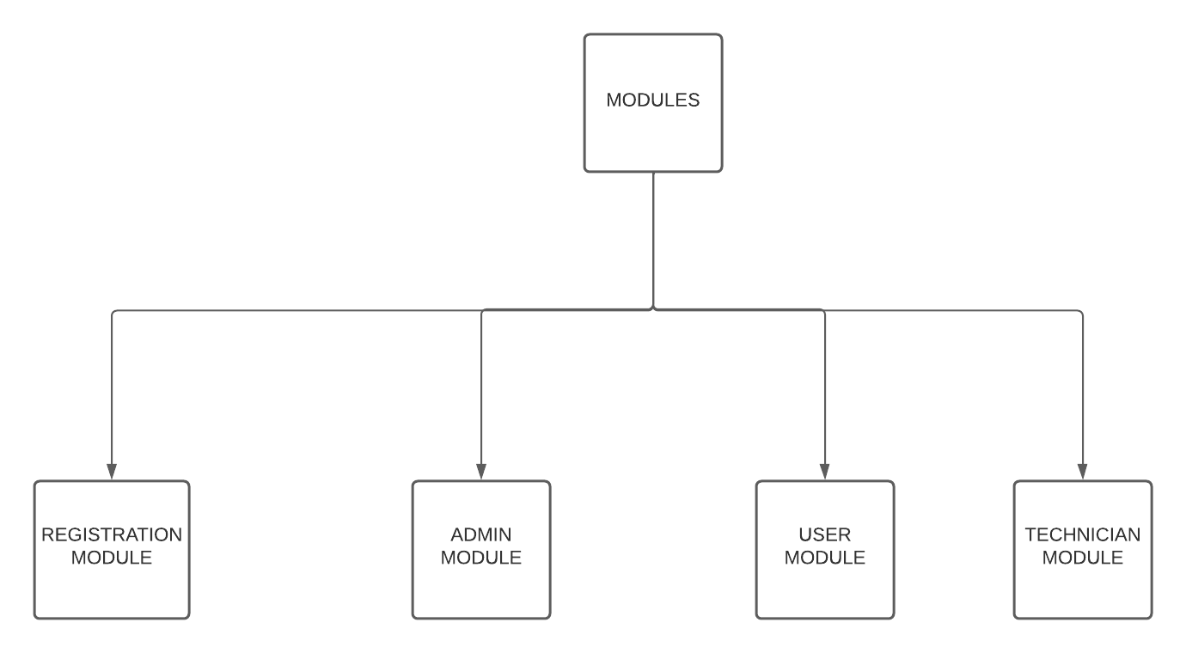

1. REGISTRATION MODULE

The proposed system contains login for existing users, service providers, and admin. If not registered on the website the user and service provider should singin into the sign-in page separately given for them to access the services. Only after successful registration, they are directed to their dashboards.

2. ADMIN MODULE

The admin module can handle the request forms raised by the users and assign them to the nearest service provider. Admin has the right to cancel the request raised by the users for inevitable reasons. Admin can also manage and handle the service providers like admin can remove the service provider according to the policies by the system and user given feedbacks. Admin can view and manage the number of users registered on the website. Admin can update the contents in the home page like text, links to social networks, and images.

Admin can view the completed services by the service providers. Report generation can also be done by the admin based on the selected dates or by the individual service providers. Admin can also generate sales reports and employee-wise reports for future growth and development.

3. USER MODULE

After registering on the website, the users are directed to their respective dashboards where they can find the request form to raise their requests. The user needs to fill in all the details in the request form to raise a request. The details are the type of appliances, brand name, nature of the problem, address, suitable date, and suitable service time. Once the form is raised it is then sent to the admin.

Users can change their details on the profile page whenever needed. Users can also change their passwords.

4. TECHNICIAN MODULE

For the service provider to get a request firstly he/she must register to the website so that the requests will be assigned by the admin based on the type of service. The service provider will get the requests from the admin once the admin assigns the task.

After completing the service raised by the user. The service provider can change the status as completed in their dashboard and update the form with the cost for the service along with the spare parts cost for the service.

Service providers can generate their reports on desired dates. So that they can use it for their personal and for their career growth. This system helps the small and skillful service providers to grow in their career and income aspects.

VI.  **Features in the proposed system**

In addition to the already existing model features some additional features are added to the proposed system.

A. PAYMENT

In already proposed systems, the type of payment is cash-based where the customers give the cash to the service provider, and then service providers will be charged by the website for their service. Instead of that our proposed system contains online payment.Traditional payment methods such as cash or checks are much slower than electronic payments. When making online payments, users are not bound by time or location. Electronic payments can assist you in providing clients with a more convenient payment experience.

B. REQUEST HISTORY

In the user dashboard, the user can view the request history of what services he/she has done in the past and also view the requests raised currently. Appliances like RO machines need routine checks so that by this request history he/she can make note of the date and book for the next service when needed.

C. INVOICE OF SERVICE

Once the admin assigns the request to the service provider. He takes care of the service after the successful completion he/she will update the amount for the service done and will update the amount spent for spare parts. The charges are service charges, parts charges, and other charges. By summing up all the charges the user will be given the total amount in the invoice of services.

D. SEARCH USING SERVICE NUMBER

When the service is completed, the service provider needs to update the form as completed. If the service provider can't find the service because of many requests raised, he/she can search through the search option given in the service provider dashboard providing the service number and updating the form as completed.

This search option is also enabled in the admin so that by using the service number he/she can track and view the request form whenever needed in the future.

E. BETWEEN DATES REPORT

Admin can generate the reports between the given dates for all the service providers so that he/she can make note of the request completed and profit earned by the service providers and the company. It helps in the growth of the company and future enhancements.

F. EMPLOYEE WISE REPORT

Admin can also generate the Employee wise report according to the feedback given by the users and service completed so that the admin can provide them with rating. So that in the future the best service provider gets more opportunities for getting service.

G. SALES REPORT

Admin is responsible for generating the sales report. When the management requires the sales report for a certain period, the admin can instantly generate a sales report for that period. By this, the management can see the profit gained and improve their service based on the reports.

VII. **Conclusion**

To make it easier for consumers to identify suitable service providers, this proposed system gives detailed information that enables them to have their needs met quickly. This proposed system makes the user easily make service requests and makes the service done more quickly by a skillful service provider. Online payment makes the system contrast to existing systems. As a result, this application looks to be more alive than the current system.

VIII. **Reference**

[1]. Sheetal Bandekar and Avril D'Silva-

"Domestic Android Application for Home Services",

International Journal of Computer Applications, Vol-148, No-6, August 2016,

ISSN 0975-8887.

[2]. Bo Zhang, Ruihan Yong, Meizi Li, Jianguo Pan, and Jifeng Huanglaa-

"A Hybrid Trust Evaluation Framework for E-commerce in Online Social Network", IEEE. Translations and content mining are permitted for Academic Research, PP. 2169-3536, 2016.

[3]. Shahrzad Shahriari, Mohammadreza Shahriari, and Saeid Gheiji, "Ecommerce And It Impacts on Global Trend And Market",

International Journal of Research - Granthaalayah, Vol-3, No-4, April 2015.

[4]. N. M. Indravasan, G Adarsh, C Shruthi and K Shanthi-

"An Online System for Household Services",

International Journal of Engineering Research & Technology (IJERT), May 2018, ISSN 2278-0181.

[5]. Mohammed Sayagh, Bram Adams Polytechnique Montreal-

"Multi-layer Software Configuration", Empirical Study on WordPressSCAM 2015, Bremen, Germany.

[6]. Sujit Kumar Basak, Irene Govender-"Examining the Impact of Privacy, Security, and Trust on the TAM and TTF Models for E-Commerce Consumers", A Pilot Study, IEEE, 2009.

[7]. Dejan Kovachev and Ralf Klammadriano- " Beyond the ClientServer Architectures: A Survey of Mobile Cloud Techniques

", workshop on mobile computing in 2011.

[8]. Haizheng Li and Han Zhang-

" How Do People Select Their Payment Methods in Online Auctions? An Exploration of eBay Transactions ", Proceedings of the 37th Hawaii International Conference on System Sciences – 2004.

[9]. Teddy Mantoro, Admir Milišić, Media A. Ayu-

“ Online Payment Procedure Involving Mobile Phone Network

Infrastructure and Devices ", IEEE 2010.

[10]. Chenggang Zhen,Peng Cheng-

"Construction of campus trading platform based on third-party online payment ",2nd International Conference on Industrial and Information Systems, IEEE,2010.

[11]. C Ramadevi, V Vijayan, “Design of decoupled pi controller for quadruple tank system- International Journal of Science and Research, Volume 3, Issue 5, Pages 318-323, 2014.